Dynamic Timeline Visual Overview
The Dynamic Timeline Power BI Visual gives analysts a flexible way to display time-based data on an interactive timeline. Any date/time fields can be used, with the timeline automatically adjusting to cover the range of your data. Event markers can be grouped into categories, colour-coded and enriched with additional details, making it easy for users to explore the timeline and quickly pick out what’s important. It can be used to visualise schedules, spot clusters and patterns in your data, or identify outlying patients.

Quick Tour







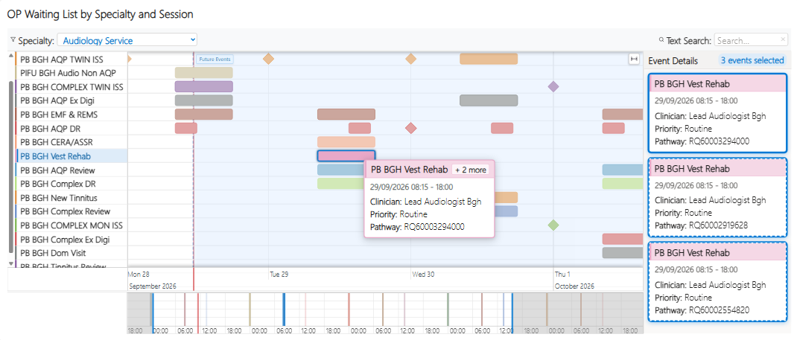
- Event Markers – Events with a start and end time are shown as rectangular time ranges. Events without an end date are shown as diamonds. The timeline can be zoomed in and out with the scroll wheel and dragged with the mouse.
Colours are allocated per group, but marker-specific colours can be defined in the data.
- Groups – Markers can be split into groups and, optionally, subgroups. Groups containing subgroups can be expanded and collapsed.
- Tooltips – Hovering over markers will show event details in a tooltip. Overlapped markers are flagged by a badge in the top-right corner (eg. ‘+ 2 more’.)
- Details Panel – Clicking on a marker will show event details in the right-hand panel. Where markers are overlapped, all events at the mouse location will be shown as separate cards. Hovering over a card will highlight its corresponding marker.
- Text Search – Text filter with instant feedback. Matched events are highlighted in yellow on the timeline and listed in the details panel.
- Top Level Group – An in-built category filter which allows the user to quickly switch between category items. This feature also safeguards against overloading Power BI and causing data errors.
- Mini Timeline – Gives a quick overview of the entire timeline. Each event is plotted on this timeline as a vertical line, which makes it easy to identify clusters of events. The timeframe can be quickly adjusted to focus on an area of interest.

